# 

# 

# Workshops

Presented by:

**Engineering Workshop**

Video: mp4

Location: Currently under Google Drive MB (need to add to portal)

Size: 332

**Speakers**

1. Two RBC representatives

2. Maayan Harel, Program Manager, Aerospace & Defense, Enginuity Inc.

3. Dawn Henwood, Self-employed, Communications and Learning Consultant

**Schedule**

4:00 - 4:10 Intros to speakers and housekeeping

4:15 - 4:45 Personal Branding, RBC

4:45 - 5:45 Resumes, Maayan

5:45 - 6:45 Technical Writing and Cover Letters, Dawn Henwood

6:45 Wrap-up

**Cover letter handout by Dawn**

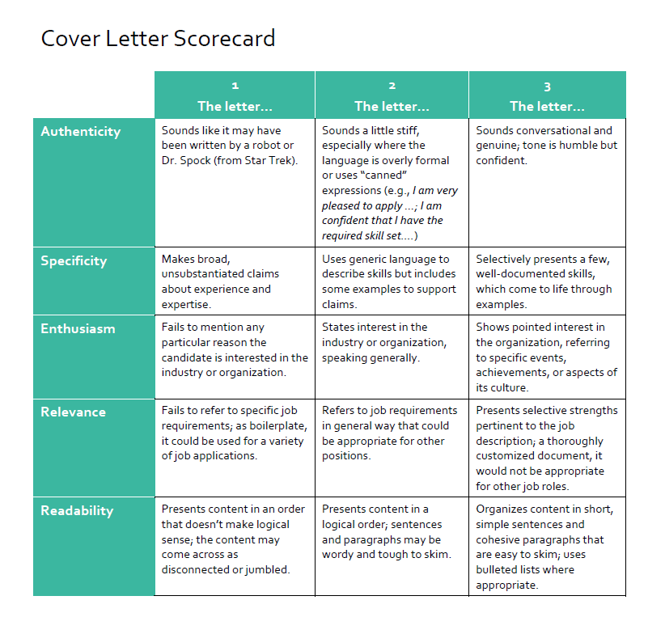

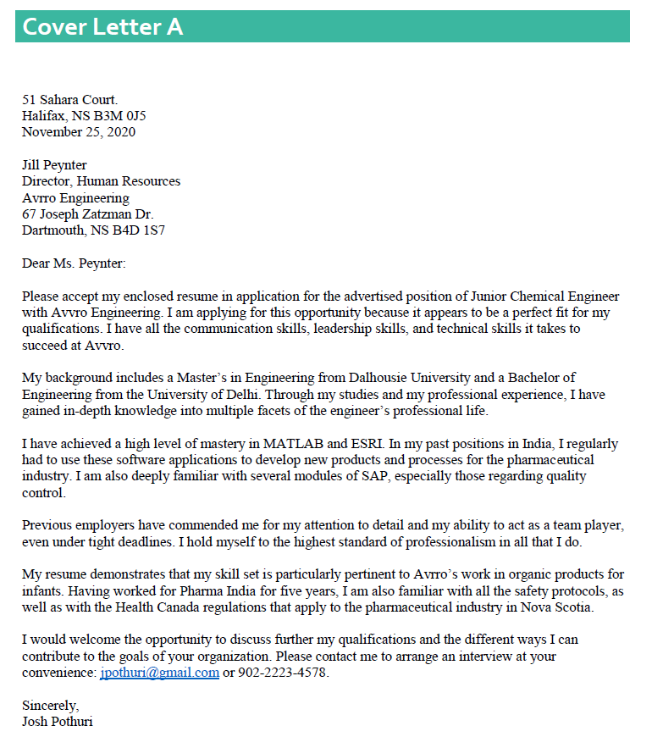

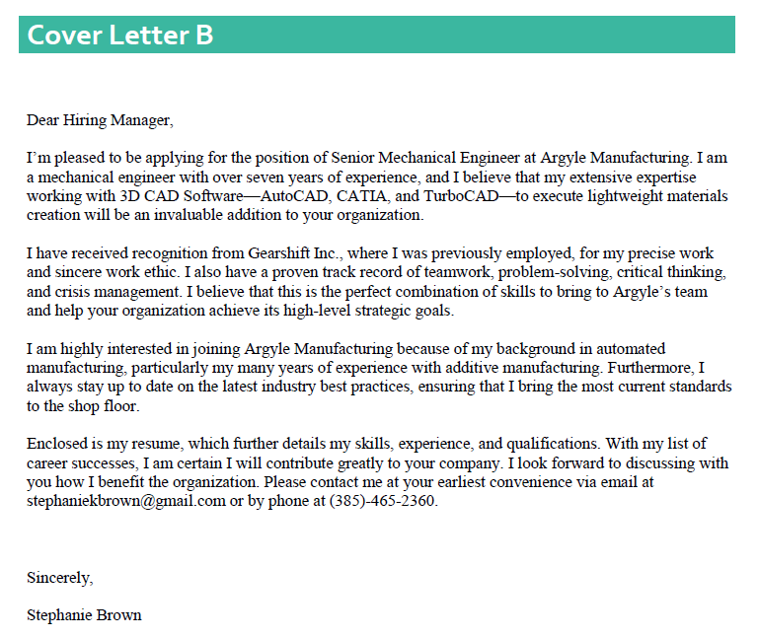

**Job Search Workshop with Gerald Walsh**

Emails

**In-person**

Hello,

We are hosting an **Engineering Workshop** on **December 1st from 4:00 – 7:00 p.m.** (Please arrive at 3:45 at the latest) at the Bedford Farmers Market on the Bedford Highway. This workshop will be held on the second-floor banquet space overlooking the Bedford Basin.

Maayan Harel and Dawn Henwood are partnering with to us to put on this workshop for you. The three hours will focus on personal branding, resumes, and cover letters. Maayan is the Program Manager, Aerospace & Defense at Enginuity Inc. and Dawn is a self-employed Communications & Learning Consultant, helping clients hone their technical and business writing skills.

Coffee, water, juice and light refreshments will be provided, and we ask that you bring your **most up-to-date resume, a pencil and notebook** to take notes throughout the session.

**Parking:** There is free parking, and it is on transit route for those using bus 8, 90 or 91. We kindly ask that you refrain from parking in the front or back parking lot of the Farmers Market or Garden Centre. This is only a 2-hour parking. You can park your car at the parking lot to the right of the Irving. It’s best to enter directly from the Bedford Highway.

Space is limited to 25 people for this workshop, so if you’d like to join **please respond** **with your RSVP (First Name, Last Name, Discipline)** confirming your spot as soon as possible!

Looking forward to this session!

Thanks,

**Virtual**

Hello,

We are hosting a **Virtual** **Engineering Workshop** on **December 1st from 4:00 – 7:00 p.m.**

Maayan Harel and Dawn Henwood are partnering with to us to put on this workshop for you. The three hours will focus on personal branding, resumes, and cover letters. Maayan is the Program Manager, Aerospace & Defense at Enginuity Inc. and Dawn is a self-employed Communications & Learning Consultant, helping clients hone their technical and business writing skills.

Please open the Zoom link five minutes prior to the start time with your refreshments ready so we can begin the workshop in a timely manner. By Friday, an invitation with the Zoom link and passcode will be sent once we receive all your RSVPs.

We ask that you have your **most up-to-date resume** handy**, a pencil and notebook** to take notes throughout the session or whatever method of notetaking you prefer.

**Recommendations for virtual webinars:**

* Clean up and remove any items in your camera view that may be a distraction to other webinar participants
* Ensure minimal background noise and movement
* Ensure your mic or headset is working properly - you may want to test it out on Zoom prior to the webinar

Space is limited to 25 people for this workshop, so if you’d like to join **please respond** **with your RSVP (First Name, Last Name, Discipline)** confirming your spot as soon as possible!

We **strongly encourage** you all to turn on your video when you want to speak, ask questions and engage. We want to imitate the in-person experience as much as possible, but we need your help. This is an interactive workshop so please don’t hesitate to speak up and **turn your video on.**

Looking forward to this session!

Thanks,

**Following Workshop**

Good morning,

Thank you for joining us for the Virtual Engineering workshop! We hope you enjoyed it. 😊

We would love to hear your thoughts, so here is a link to our survey: <https://www.surveymonkey.com/r/3TQCY89>

As promised, the video will be shared with all of you via Google drive and the documents Dawn Henwood provided in the chat room as well as the pdf of Maayan Harel’s slides are all attached to this email.

Thank you again for joining us and if you have any additional follow up questions, please don’t hesitate to reach out.

In-person

Hello «First_Name»,,

On behalf of the Halifax Partnership’s Connector Program I would like to extend an invitation to the Gerald Walsh Job Search Workshop on Tuesday, March 10th, from 8:30 am to 4pm. The workshop will be held at the Bedford Basin Farmers Market, 397 Bedford Highway, Halifax, NS, B3M 2L3. Lunch will be provided. It is on routes 8 and 90 of Halifax Transit, and parking is available in the empty lot by the gas station (please do not park at the Farmers Market). There is no cost for this workshop.

Gerald Walsh is an executive recruiter with a mission to help community-based organizations find the right people and to help individuals find the right careers. He has run numerous workshops to help individuals navigate the open and hidden job markets, how to apply for a job, and how to negotiate your contract. You will also receive a complimentary copy of Gerald's book "PINNACLE - How to Land the Right Job and Find Fulfillment in Your Career " which covers the information discussed in the workshop.

If you’re interested in attending, please register at [Eventbrite](https://www.eventbrite.ca/e/gerald-walsh-job-search-workshop-tickets-97801943245?ref=estw). The password for the event is **Connector2020**. Please note that the event is capped at 20 participants, so register early to secure your seat.

If you have any questions, please let me know. Thank you very much, we’re looking forward to seeing you at the Workshop.

**Nada Halaweh**  
Program Coordinator - Connector Program

Virtual

Hello «First_Name - Connectee»,

On behalf of the Halifax Partnership’s Connector Program, I would like to extend an invitation to a series of Job Search Workshops with Gerald Walsh from Oct 20th, to Oct 29th. The workshops will be held virtually on October 20th, 22nd, 27th and 29th at 9am to 10:30am each day. There is no cost for this workshop.

Gerald Walsh is an executive recruiter with a mission to help community-based organizations find the right people and to help individuals find the right careers. He has run numerous workshops to help individuals navigate the open and hidden job markets, how to apply for a job, and how to negotiate your contract.

If you’re interested in attending, please register on the Eventbrite page [here](https://us02web.zoom.us/webinar/register/WN_ehzp-OhARg-PqFev21UddQ). Please note that the event is capped at 20 participants, so please register early to secure your seat.

If you have any questions, please let me know. Thank you very much, we’re looking forward to seeing you –virtually– at the Workshop.

**Schuyler H Smith** (he/him/his)

**and the Connector Team**  
Program Coordinator – Connector Program

**HΛLIFΛX  
PARTNERSHIP**

Full link to event: https://us02web.zoom.us/webinar/register/WN_ehzp-OhARg-PqFev21UddQ