# 

# 

# We Are All Connectors Campaign

Presented by:

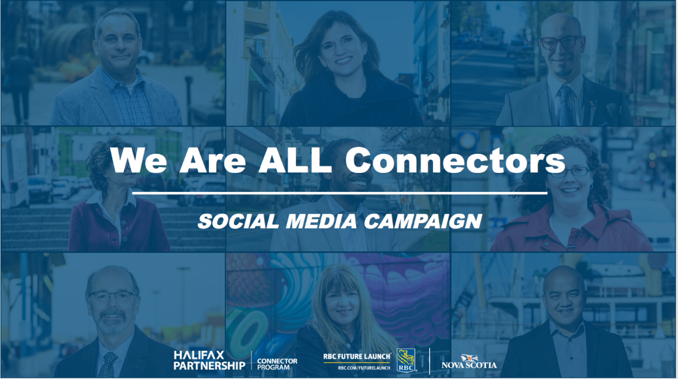

**Objective**

The Connector Program to post photographs of engaged Connectors monthly to:

* Re-engage and recognize Connectors as community leaders and supporters of talent retention
* Increase awareness of the Connector Program to the local business community
* Gain new Connectors through social media campaign

Monthly posts will include a quote by the Connector expressing the importance of the program.

**Goals**

* The target for each post is a minimum of **15 likes**, **five comments** and **five re-tweets/shares**
* To increase traffic to Connector website
* To gain new Connectors every three months

**Channels**

* We will use **Twitter,** **Facebook**, and **LinkedIn** as our primary handles for the campaign

**Timeline**

* Social Media campaign will run **December 2017-18.**
* Posts will be scheduled for the first week and last week of the month.

**Analytics**

**An increase +6% in unique page views to HalifaxPartnership.com/ConnectorProgram**

* **203 likes *(Dec 2017 – Nov 2018)***

Since the launch date (Dec 4, 2017), the campaign has seen, on all platforms, a total of 158 Likes and 46 Re-Tweets/shares.

*Please note that there were not any posts were made in April, May, and June due to the launch of RBC Future Launch - campaign graphics were not updated with RBC’s new branding.

* **• Twitter: 105 Likes, 42 Re-Tweets**
* **• LinkedIn: 53 Likes, 5 Shares**
* **• Facebook: 45 Likes, 9 Shares**

**Best Performing Post on Facebook:**

**Donick Abad (Nov 13, 2018)**

* **1,673** Reach
* **137** Reactions, comments & shares (*this includes total of all shared posts)*
* **113** Likes (7 Love)
* **6** comments
* **3** shares
* **226** post clicks (**28** photo views, **17** link clicks, **181** other clicks (page title and/or “see more”)).

*\*****Best performing non-boosted Facebook post (most engagement) in 2018 & 2017.***

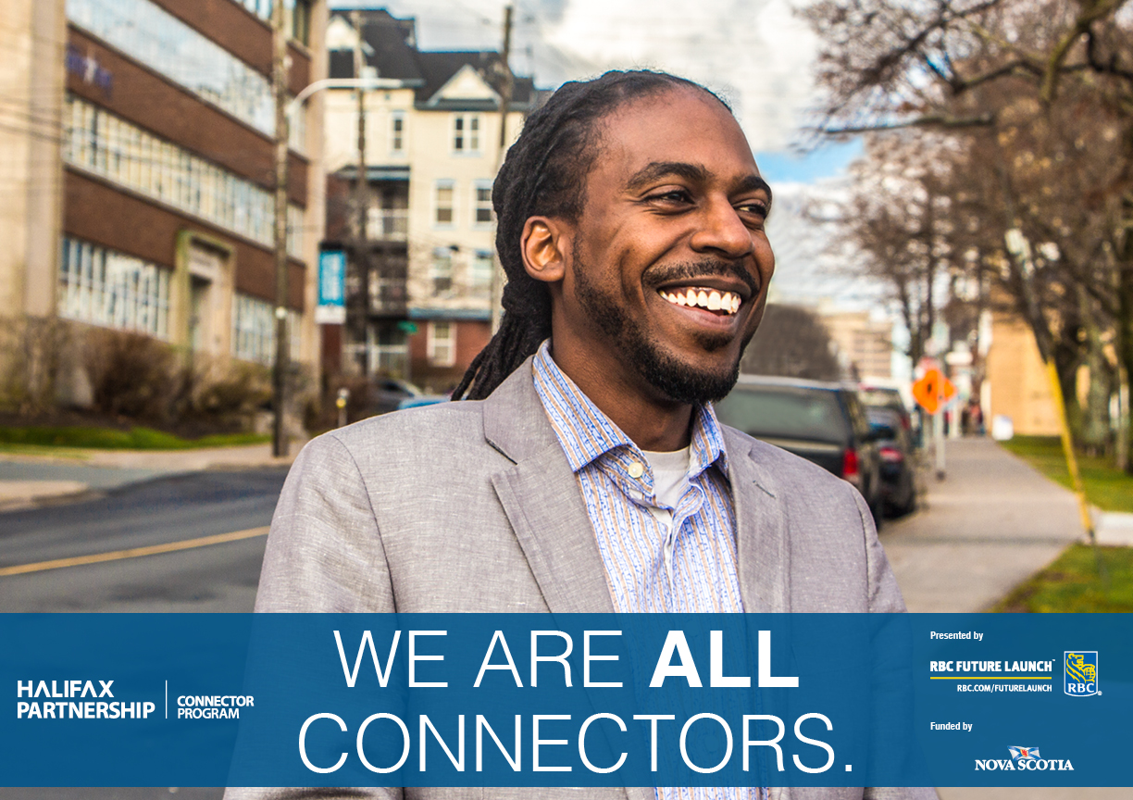

**Mervin Quinlan**

**Twitter:**

The #ConnectorPrgm allows me to meet new people, learn about various cultures in our beautiful city, & keeps me up-to-date on hiring trends in the workforce. – Mervin Quinlan @nsmortgage Become a #Connector today! <http://ht.ly/4STB30m5uj6> #WeAreAllConnectors #RBCFutureLaunch @RBC

**Facebook/LinkedIn:**

The #ConnectorPrgm allows me to meet new people and learn about the many cultures in our beautiful city. It also keeps me up-to-date on hiring trends in the workforce as well as how the various university programs have evolved since I have graduated. – Mervin Quinlan.

Become a #Connector today! <http://ht.ly/4STB30m5uj6> #WeAreAllConnectors #RBCFutureLaunch #ConnectorPrgm @RBC

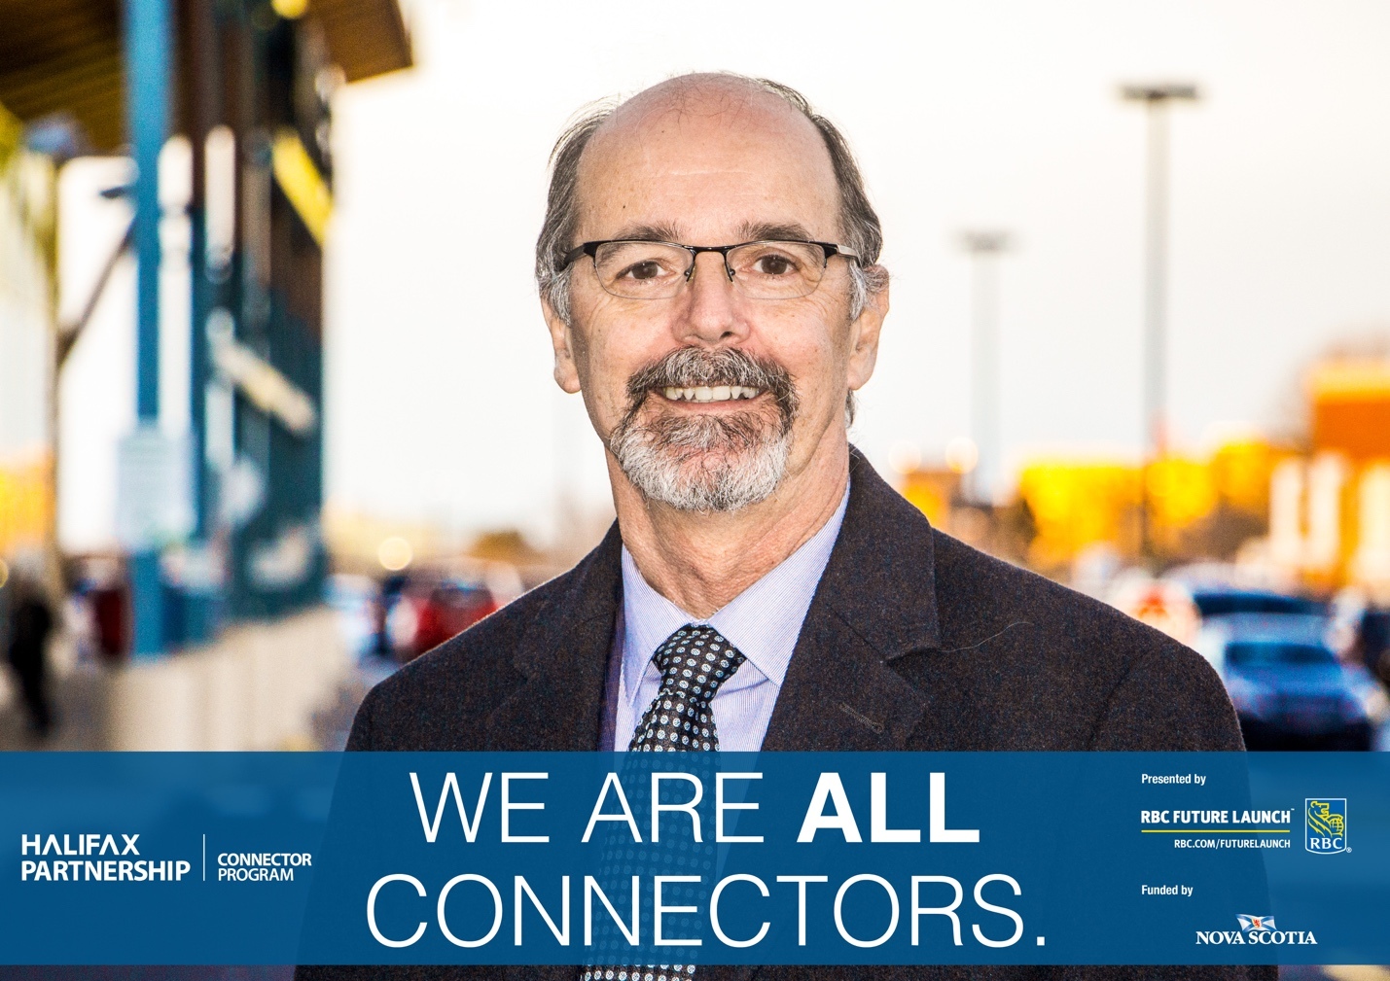

**Pat d'Entremont**

**Twitter:**

“The idea of teaching people how to find employment by face-to-face communication as opposed to relying on job ads appealed to me right from the start.” – Pat d’Entremont @NicomITPat, Our very first #Connector. Become a Connector today!: <http://ht.ly/4STB30m5uj6>

#WeAreAllConnectors #RBCFutureLaunch @RBCToday

**Facebook/LinkedIn:**

“The idea of teaching people how to find employment by face-to-face communication as opposed to relying on job ads appealed to me right from the start. It shows people who have little networking experience the power of getting what you want, a job for example, via personal networks.” – Pat d’Entremont, the #ConnectorPrgm very first #Connector. Learn all about becoming a Connector today! <http://ht.ly/4STB30m5uj6> #WeAreAllConnectors @RBC #RBCFutureLaunch #Halifax #NS

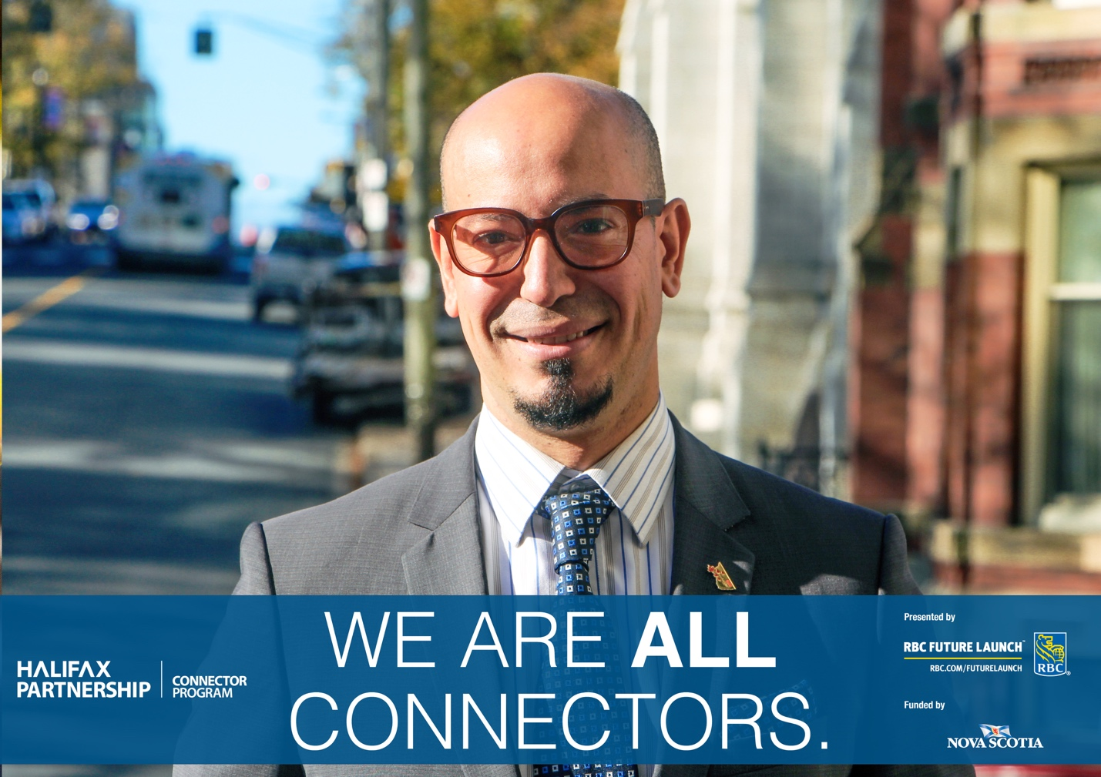

**Rany Ibrahim**

**Twitter:** *“Making a connection is a gratifying feeling as the energy that exists when people feel seen, heard, and valued.”*– Rany Ibrahim, #Connector and recipient of @MyHFXExperience 2017 Top 25 Immigrants Award. For information on becoming a Connector, visit: <http://ht.ly/4STB30m5uj6> @RanyIbrahim #WeAreAllConnectors #ConnectorPRGM @RBC #RBCFutureLaunch #Halifax #NS

**Facebook/LinkedIn:**

*“There are many invisible threads that makes the strongest ties connecting us in our community. Being a connector is a rewarding privilege, with the trust, respect, and kindness to open up and share our most vulnerable and most powerful selves, to discuss possibilities and propose opportunities. Making a connection is a gratifying feeling as the energy that exists when people feel seen, heard, and valued. The American philosopher William James once said: “We are like islands in the sea, separate on the surface but connected in the deep.”  –*Rany Ibrahim, Columnist, Entrepreneur, Public Servant, Professor, #Connector and recipient of @MyHFXExperience2017 Top 25 Immigrants Award. For information on becoming a Connector, visit: <http://ht.ly/4STB30m5uj6> @RanyIbrahim #WeAreAllConnectors #ConnectorPRGM @RBC #RBCFutureLaunch #Halifax #NS

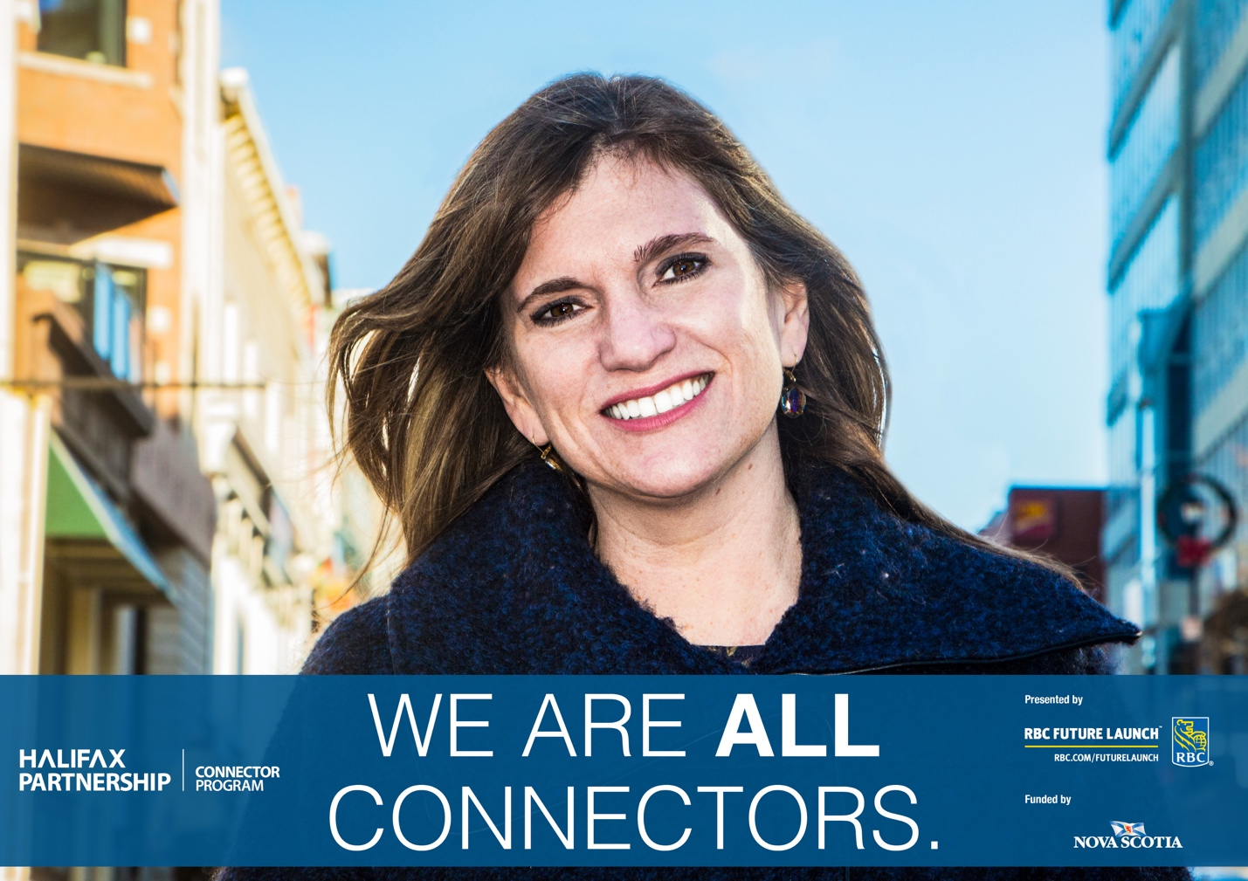

**Sara Napier**

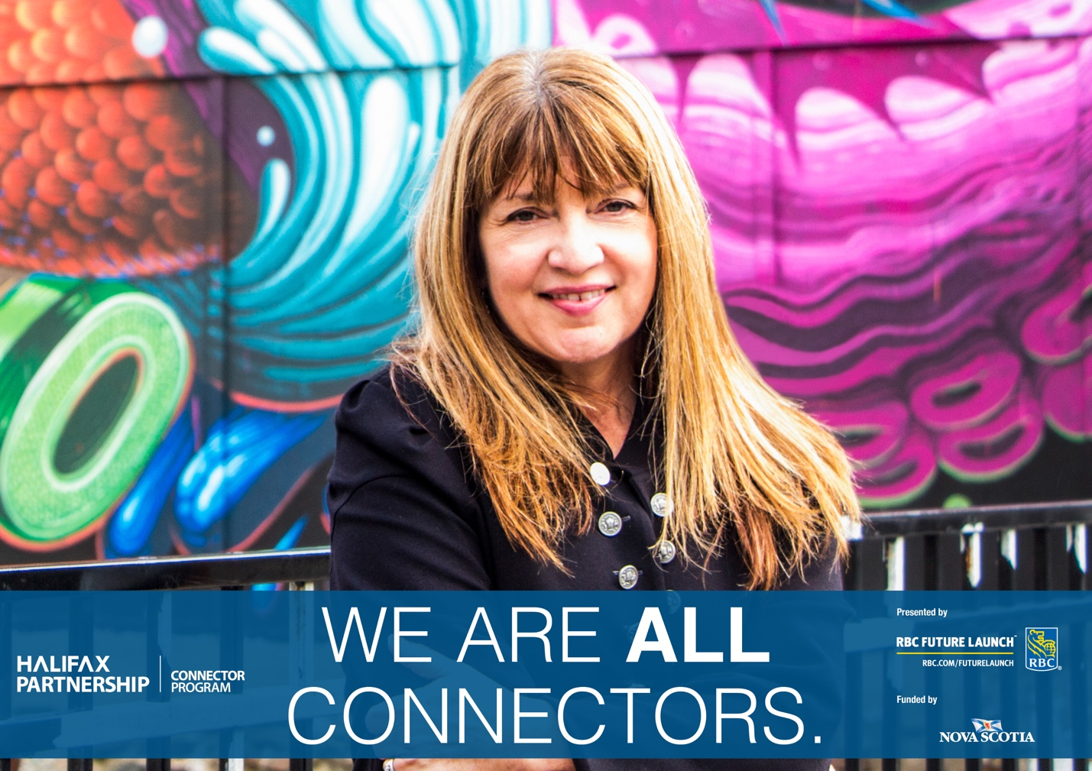

**Shelagh McCorry**

**Twitter/Facebook/LinedIn:**

*“I’m lucky to work and live in a place I love. I want others to have that same opportunity.”* Become a #Connector today! <http://ht.ly/4STB30m5uj6>

– Shelagh McCorry, Recipient of the 2016 Game Changers Award for Super Connector. #WeAreAllConnectors #ConnectorPrgm @RBC #RBCFutureLaunch #Halifax #NS @scubashe

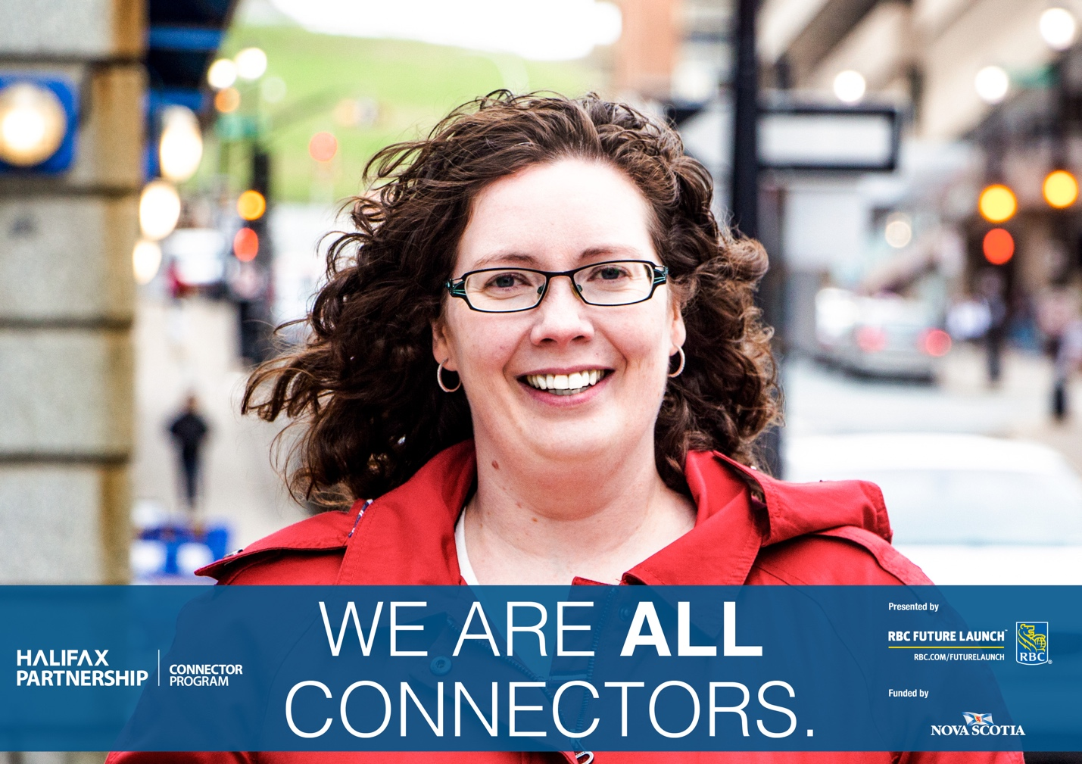

**Krista Martin**

**Twitter:**

*“I love the Connector Program. It allows me to meet fantastic people while at the same time helping them grow their professional network with “first” connections.”*– Krista Martin For information on becoming a Connector, visit: <http://ht.ly/4STB30m5uj6>

@KristaRecruits #Connector #WeAreAllConnectors #ConnectorPRGM #Halifax #NS @RBC #RBCFutureLaunch

**Facebook/LinkedIn:**

*“With so many pieces of job applications happening online these days, it’s more and more difficult to have those face-to -face interactions. Being new to a country would only compound that challenge – which is why I love the Connector Program. This program allows me to meet fantastic people while at the same time helping them grow their professional network with “first” connections.” –*Krista Martin For information on becoming a Connector, visit: <http://ht.ly/4STB30m5uj6>

@KristaRecruits#Connector #WeAreAllConnectors #ConnectorPRGM #Halifax #NS @RBC #RBCFutureLaunch

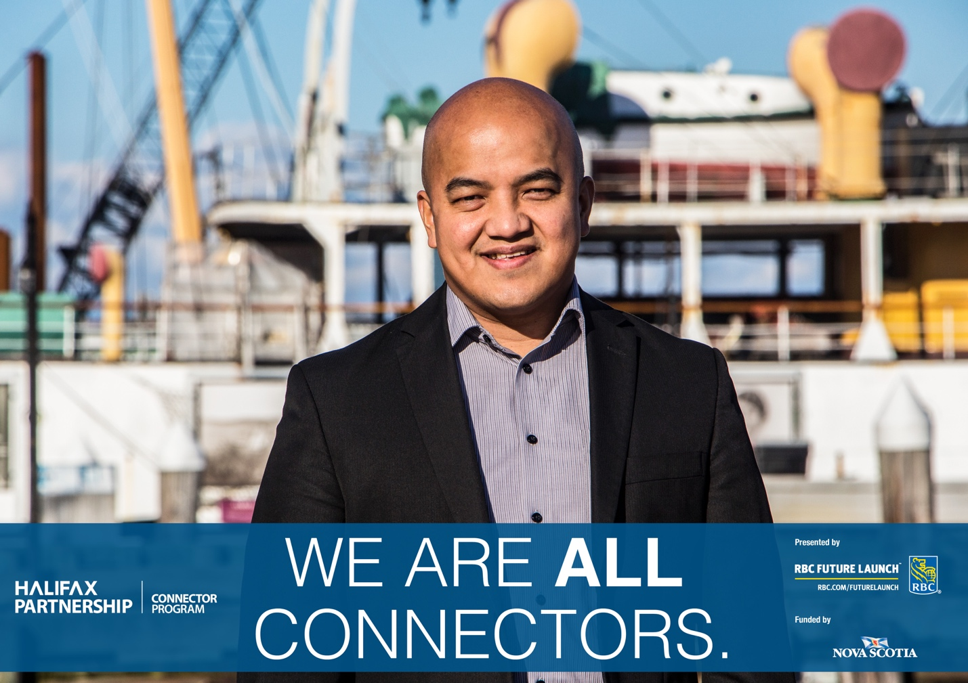

**Donick Abad**

**Twitter:**

[#ConnectorPrgm](https://twitter.com/hashtag/ConnectorPrgm?src=hash) helps employers connect to a diverse network of skilled professionals. Donick Abad, [#Connector](https://twitter.com/hashtag/Connector?src=hash) & recipient of the 2017 [@MyHFXExperience](https://twitter.com/MyHFXExperience) Top 25 Immigrants Award. Become a Connector today! [http://ht.ly/4STB30m5uj6](https://t.co/ipAJ5aBEn9) [@DonickEllen](https://twitter.com/donickellen) [@RBC](https://twitter.com/RBC) [#WeAreAllConnectors](https://twitter.com/hashtag/WeAreAllConnectors?src=hash) [#RBCFutureLaunch](https://twitter.com/hashtag/RBCFutureLaunch?src=hash)

**Facebook/LinkedIn:**

The Connector Program helps employers connect to a diverse network of skilled and ambitious professionals. – Donick Abad, #Connector and Recipient of the 2017 @MyHFXExperience Top 25 Immigrants Award. For information on becoming a Connector, visit: <http://ht.ly/4STB30m5uj6> @DonickEllen @RBC #WeAreAllConnectors #RBCFutureLaunch #ConnectorPrgm

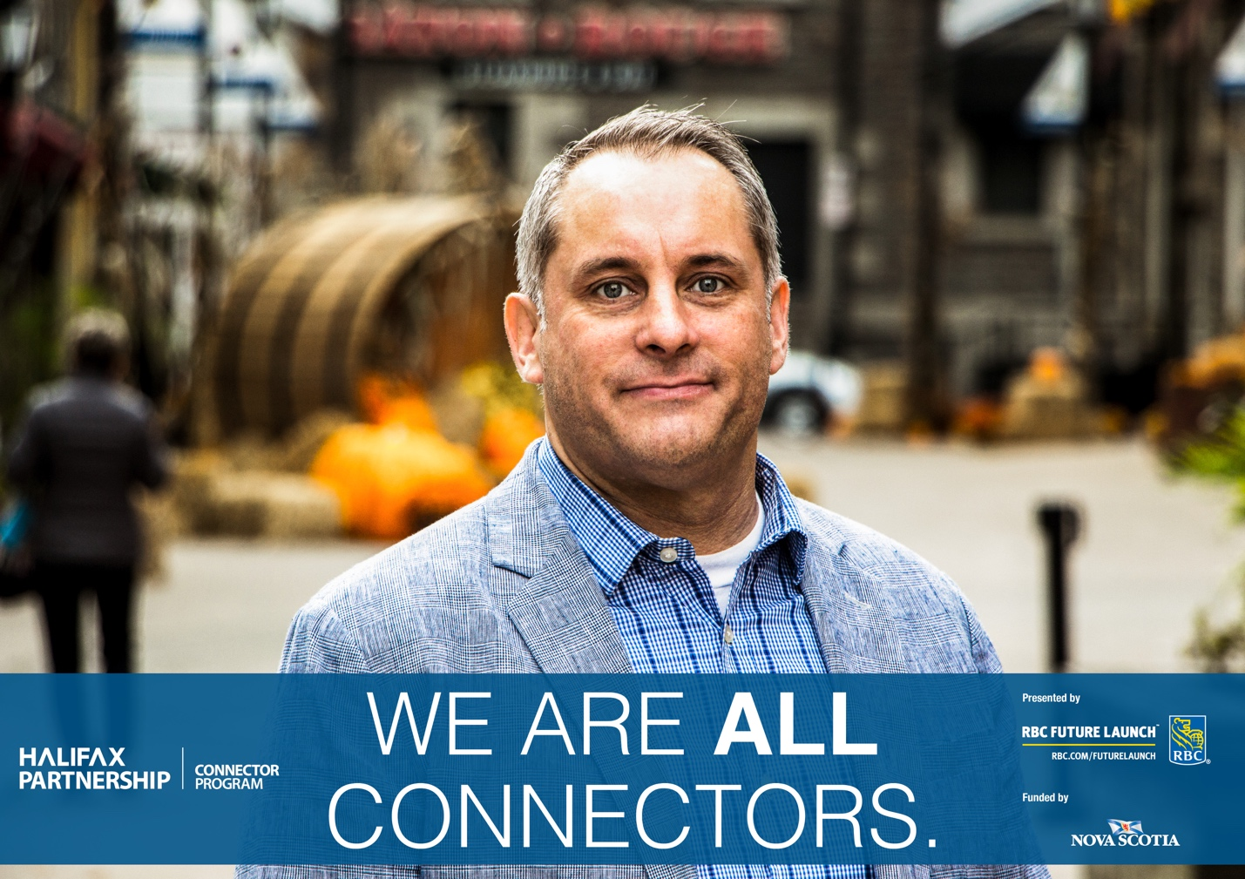

**Chris O'Shea**

**Twitter/Facebool/LinkedIn:**

“*I want to try and give back to this community based upon those that took a chance on me when I was a new grad.*” – Chris O’Shea, recipient of the 2017 Game Changers Award for Super Connector. Learn about becoming a #Connector today! <http://ht.ly/4STB30m5uj6> #WeAreAllConnectors #ConnectorPrgm @RBC #RBCFutureLaunch #Halifax #NS @UnFussyWine

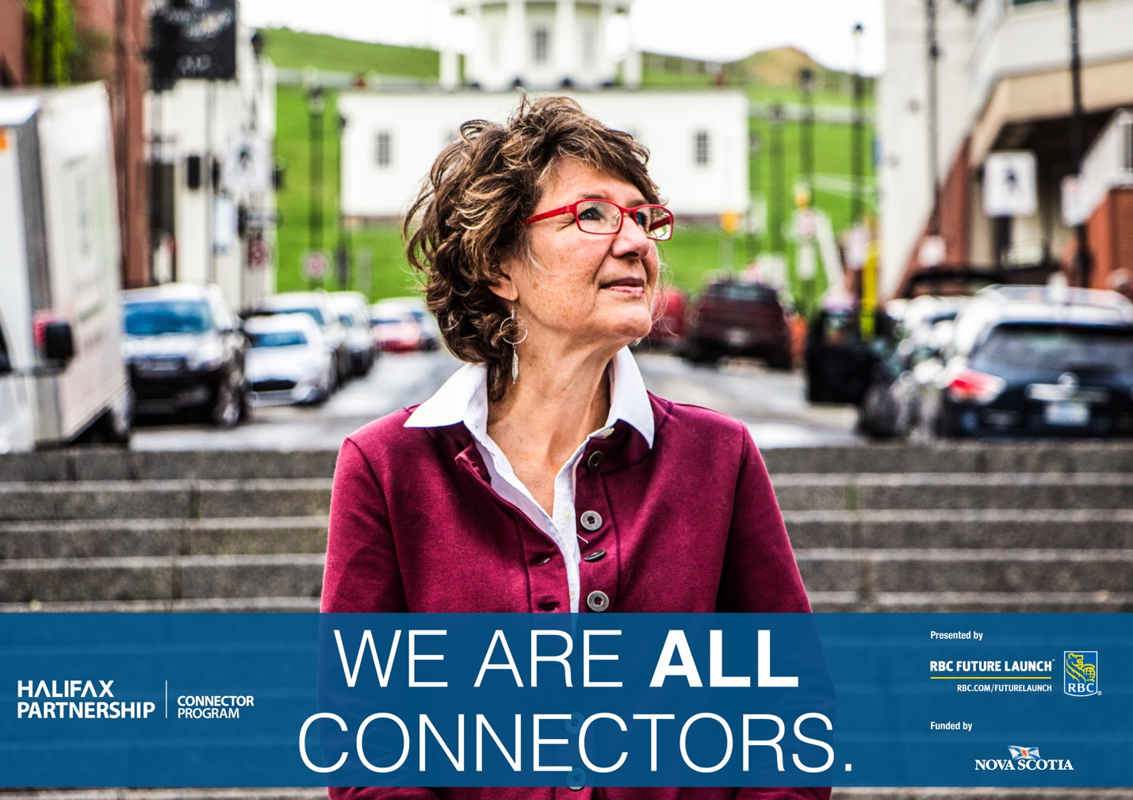

**Chris Hornberger**

**Twitter:**

*“It’s a way for employers to tap into a market that they may not otherwise have access to.” – Chris Hornberger.* Become a #Connector today! <http://ht.ly/4STB30m5uj6> *#WeAreAllConnectors #ConnectorPRGM #Halifax @RBC #RBCFutureLaunch*[*@ChristaH_1*](https://twitter.com/ChristaH_1)

**Facebook/LinkedIn:**

"It's a way for employers to tap into a market that they may not otherwise have access to." - Chris Hornberger

Become a #Connector today! <http://ht.ly/4STB30m5uj6> #WeAreAllConnectors #ConnectorPrgm #Halifax #NS #RBC #RBCFutureLaunch